# Exam 1 Review

## Dr. Wang (psychometrics, receptive fields):

Lobes of the brain: Frontal, Temporal, Parietal, and Occipital

Rostral Front; Caudal Back

The brain controls behaviors by relaying sensory information as perceived by a sensory system (somatic [touch, proprioception], visual, auditory, vestibular, olfactory, taste) through the use of neural firing. The sequence of firing patterns between synapsing neurons then dictates the organism behavior.

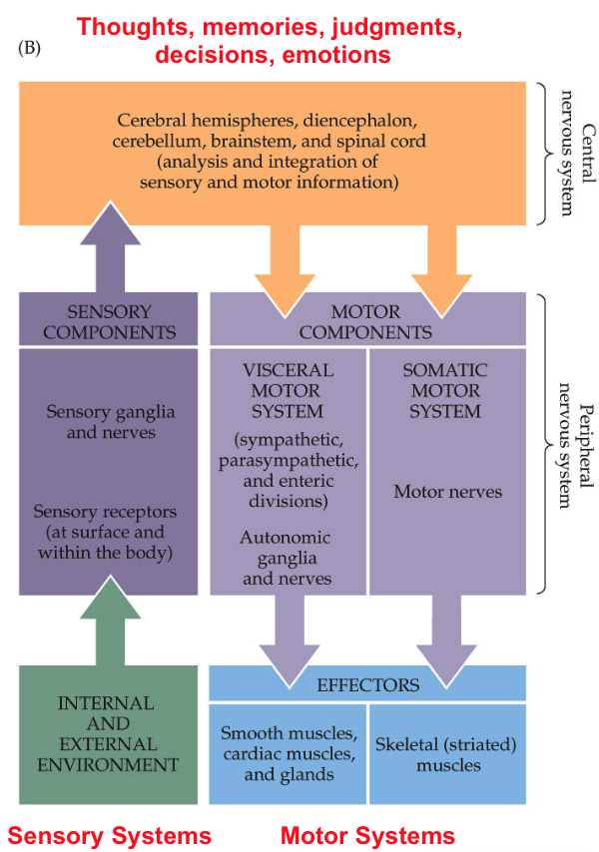

Psychophysics: scientific discipline that explores connection between physical stimuli and subjective responses

Psychometric function: provides data for psychophysics. Plots the observer’s response over the parameter of a stimulus (i.e intensity). Come in two types:

* Absolute threshold measurement: response is observed or not
* Relative threshold measurement: correct response given observations (two-alternative-forced choice [2AFC])

Discriminability index (d’): quantifiable measure of the discriminability of a stimulus independent of criterion (threshold) an observer uses. (i.e. spacing between two partially overlapping distributions… )

Signal detection theory: analyzing observer decision based on probability distributions of sample spaces.

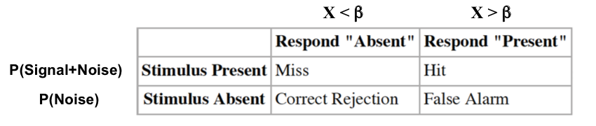

Receiver operating characteristic (ROC): analytic method to help choose optimal detection threshold. Plots P(hit) over P(false alarm) (i.e. precision).

Receptive field: field for which a neuron responds to stimulus. The size of a receptive field (in auditory neuron, for instance) is influenced by the characteristic frequency (i.e. low frequency means wider receptive field)

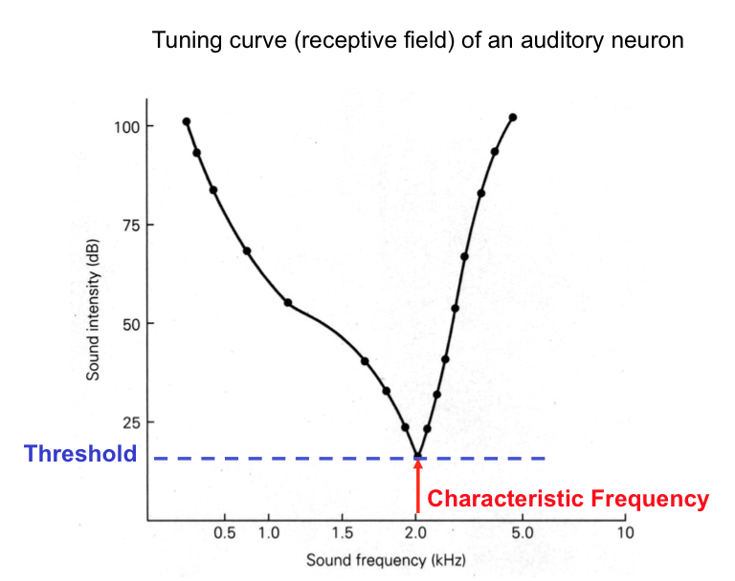

Two-point discrimination threshold: if two stimuli occur within the same receptive field, then the same response would be provided as though one stimulus were present with value equal to the (positional) superposition of all parts. Fingers have very fine discrimination thresholds whereas larger body regions such as back or thigh have much coarser thresholds.

Spike train: sequence of neural firing from a single neuron. A spike train is a discretized and binary representation of elicited action potentials from a neuron over time.

Post-stimulus histogram (PSTH) : histogram created by superimposing spike train response from multiple trials of stimulation for the same neuron, normalized by the elapsed time in the trial. Depicts a trend of firing rate for time after stimulus is presented.

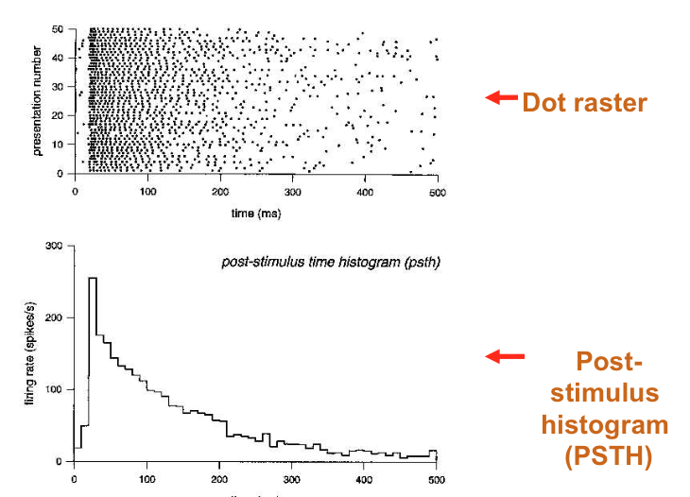

Mean firing rate: What it sounds like… the mean, of firing rates, over trial/several trials.

Phase locking: When looking closer at a spike train produced by periodic stimulus, the spikes occur at a consistent phases within the applied stimulus (i.e. slightly before the peak of a sinusoid). The period histogram represents this by overlaying multiple spike train intervals aligned by stimulus phase. 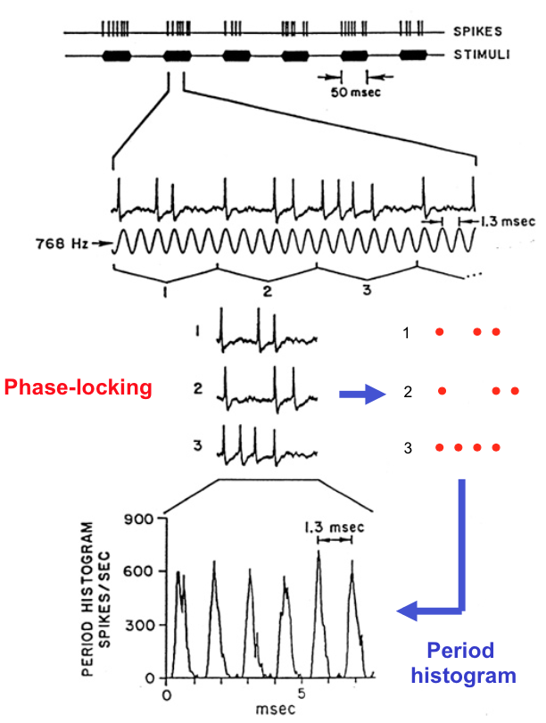

## Dr. Young (HH, cable theory, synapses):

## Dr. Kirkwood (LTP/LTD, plasticity):

Hebb’s rule: Neurons that fire together wire together

Stent’s rule: Neurons that are out of sync lose their link

Induction: Signals that trigger LTP and LTD

Expression: Mechanisms that increase or decrease synaptic strength

Maintenance: Mechanisms that maintain the changes in synaptic strength

LTP: long term potentiation of synapse, increasing the strength of an input to the post-synaptic neuron.

* Induction: Associativity through NMDA receptor (pairing low frequency stimulus with EPSP), synaptic tetanus
* Blocking: postsynaptic hyperpolarization, NMDA-R antagonists, pairing depolarization to E_ca
* Expression: additional receptors, increased unitary conductance (i.e. elevated baseline), increased conduction from synapse to recording site (i.e. better regional selectivity)

LTD: long term depression of synapse, decreasing the strength of an input to the post-synaptic neuron.

* Induction: prolonged low frequency stim, pairing with depolarization to -40 mV (eNa)
* Blocking: NMDA-R antagonists, post-synaptic Ca chelators

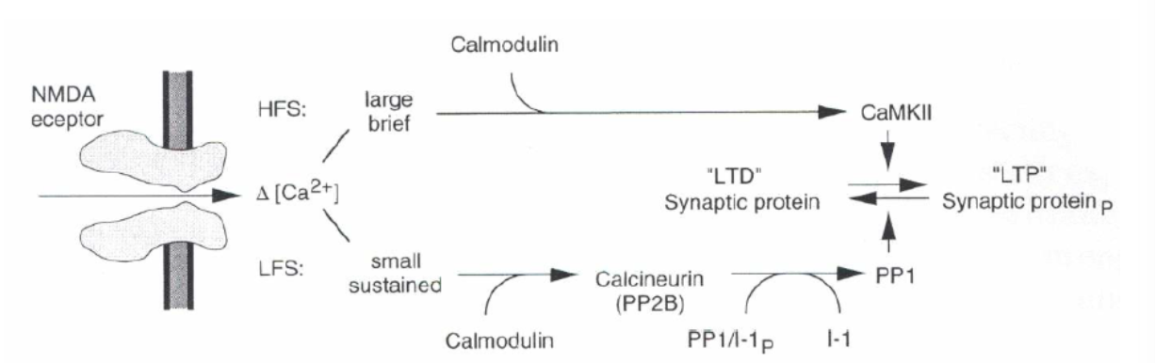

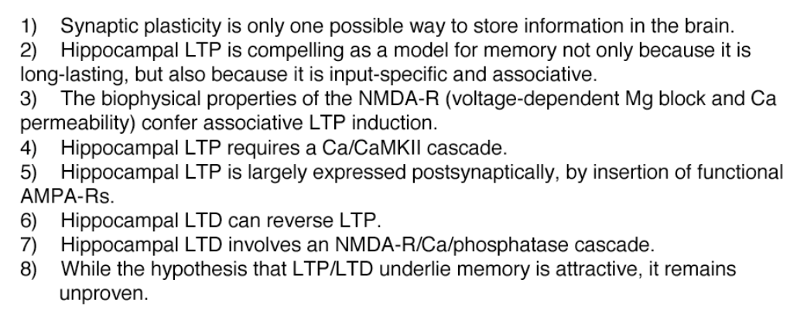

Spike timing dependent plasticity (STDP): Timing of spikes on synapsing neurons determines characteristics about their LTP/LTD. Hebbian rules. Pre then post produces LTP. Post then pre produced LTD

Sliding Threshold: As a synapse undergoes lots of LTD or LTP, a threshold shifts such that it becomes more susceptible to the opposite. This means that after experiencing LTD, LTP is easier to accomplish.

Synaptic scaling: Low firing rates increase the size of all synapses on the presynaptic neuron, high firing rates decrease the same. This preserves memory of individual synapses as they all grow in unison.

Both of the above preserve stored memories, and affect all synapses. The difference can be observed in the mechanism of response to dark rearing: sliding threshold suggests more susceptible for LTP based on a threshold shift whereas synaptic scaling suggests a stronger unitary response from the previously LTD synapses which reverses the process when an abundance of signals begin to come.

## Dr. Connor (Photoreceptors, V1/V2/V4):

Sight: Emmetropia (normal) exists when the focal point of the lens (as controlled by the ciliary muscle,) lies exactly on the fovea. If the focal point is before the fovea, myopia (near sight) exists and if it is after the fovea then hyperopia (far sight) is the case.

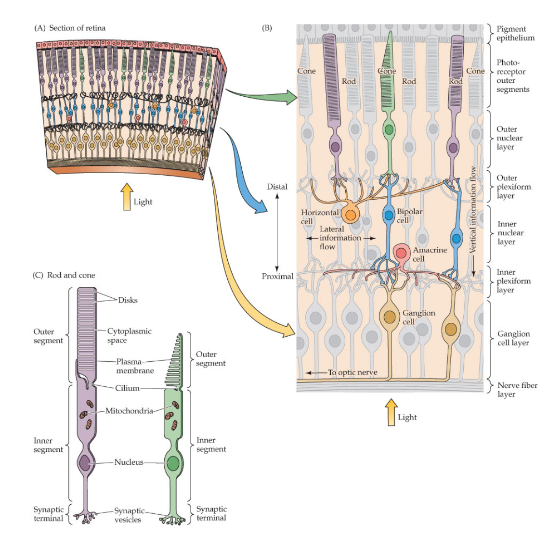

Rods: distributed everywhere except the fovea. Far more abundant than the cones, but are not sensitive to color, they are responsible for our “night vision”

Cones: concentrated within the fovea. Three categories: short (blue), medium (green) and long (red). Cones are less sensitive to light than rods, though adapt more quickly to changes in lighting

Phototransduction steps:

1. Photon stimulation of rhodopsin leads to G protein transduction
2. Activated G protein activate gGMP Photodiesterase (PDE)
3. PDE hyrdolizes cGMP into 5’-GMP which reduces cGMP concentration
4. Reduced concentrations of cGMP allow inward Na+ channels to close
5. Result is hyperpolarized photoreceptor cell

Center v off-center detection: Bipolar cells, which are on-center, become depolarized which results in a strong response from the corresponding ganglion cell. Off-center bipolar cells are hyperpolarized

Center surround activity: horizontal cells from cones in the surround inhibit the center bipolar cell when they are exposed to light. In the case that everything is exposed to light, there is still a slightly higher response rate than if there was all darkness – i.e. the on center cone has a higher weight (higher synaptic activity)

LGN (lateral geniculate nucleus): 6 aligned nuclei, numbered from ventral to dorsal. The 2 ventral portions are the magnocellular (M) channel, and the 4 most dorsal portions are the parvocellular (P) channel. These pathways are between the optic tracts and the primary visual area (17). The top two Pravocellular layers are also Koniocellular (K) layers.

The dorsal pathways are through the parietal lobe and the ventral pathways are through the temporal lobe.

K and P layers are responsible for encoding color and have fine spatial acuity and orientation tuning, curvature tuning, configural coding (determine “what”). They use an object-centric positional coordinate system. The ventrolateral pfc puts the pieces together and said “dog”

M layers are responsible for encoding motion tuning and motion direction tuning. Hand centered visual coding